**Name: VYSHNAVI BABU S**

**Roll No: 55**

**Batch: B**

**Date: 21-04-2022**

**NETWORKING & SYSTEM ADMINISTRATION LAB**

**Experiment No.: 6**

**Aim**

Familirization of basic linux commands.

**Procedure**

1. **read :** It is used to read the contents of a line into a variable.

**Syntax : read [name]**

**Output :**

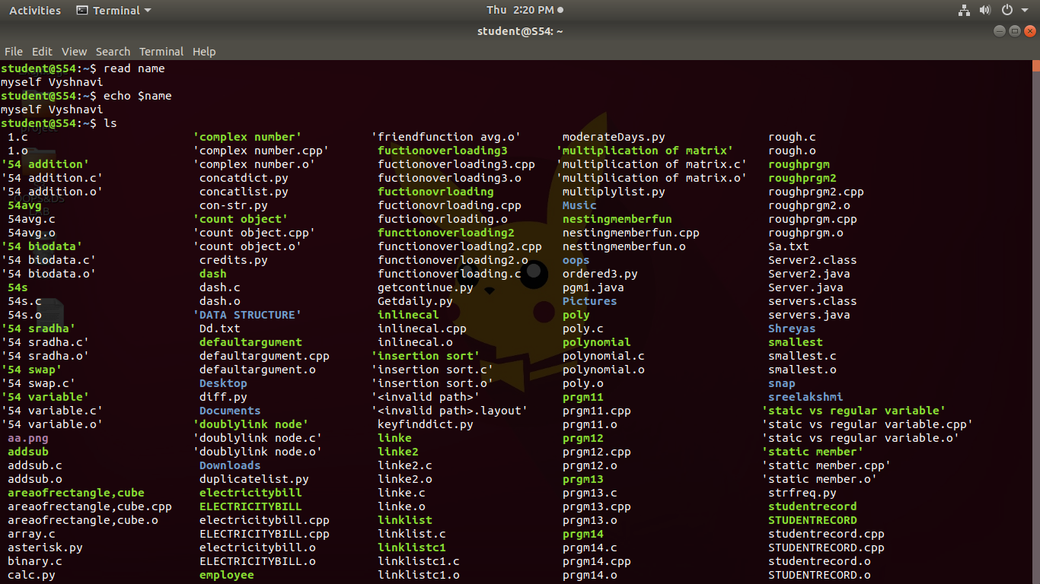

1. **locate :** It is used to locate the files by name.

**Syntax : locate [filename]**

**Output :**

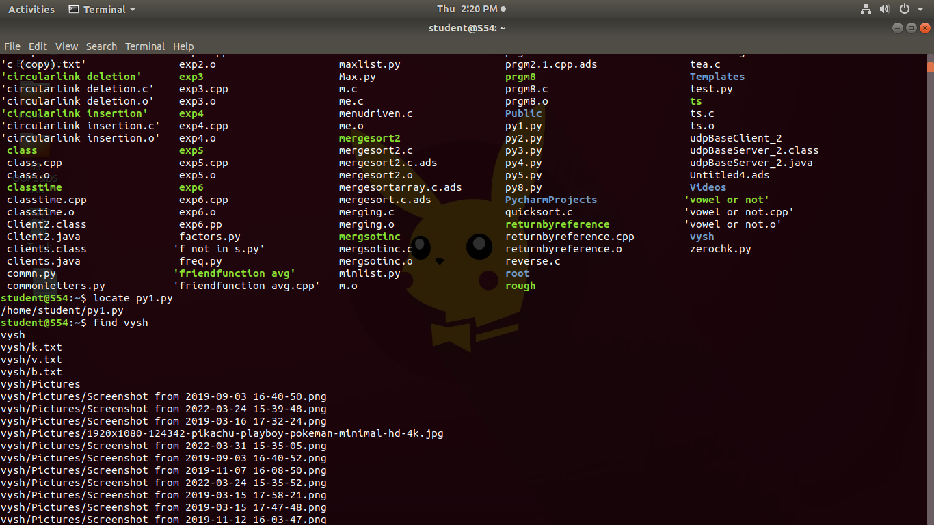

1. **locate -i py1.py :** Ignore case distinctions when matching patterns.

**Syntax : locate -i filename.txt**

**Output:**

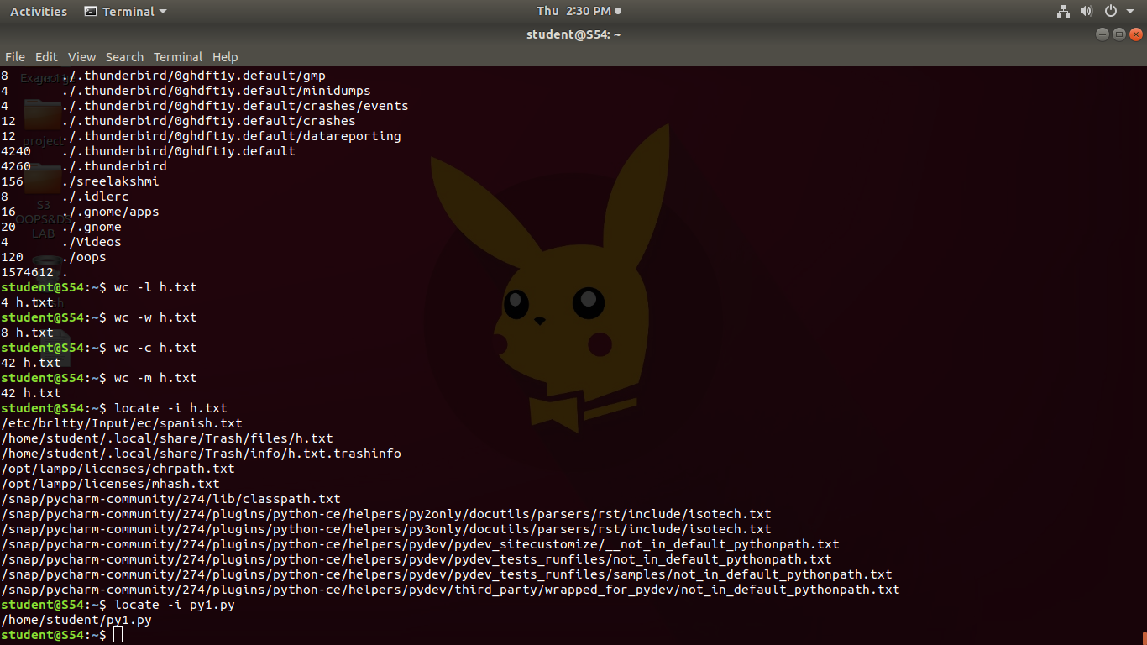

1. **find :** It supports searching by file, folder, name, creation date, modification date, owner and permissions.

**Syntax : file filename.txt**

**Output:**



1. **grep is h.txt :** It is used to search text and strings in a given file. In other words, grep command searches the given file for lines containing a match to the given strings or words.

**Syntax : grep <word in txt file>< filename.txt>**

**Output:**

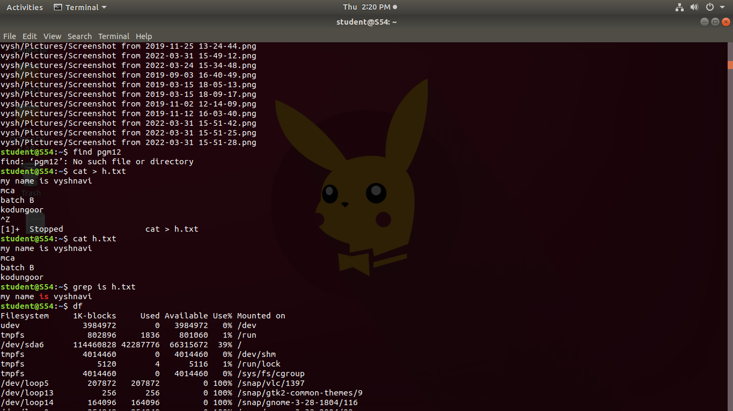

1. **grep -i is h.txt :** Ignores, case for matching.

**Syntax :** grep -i <word in txt file><filename.txt>

**Output:**

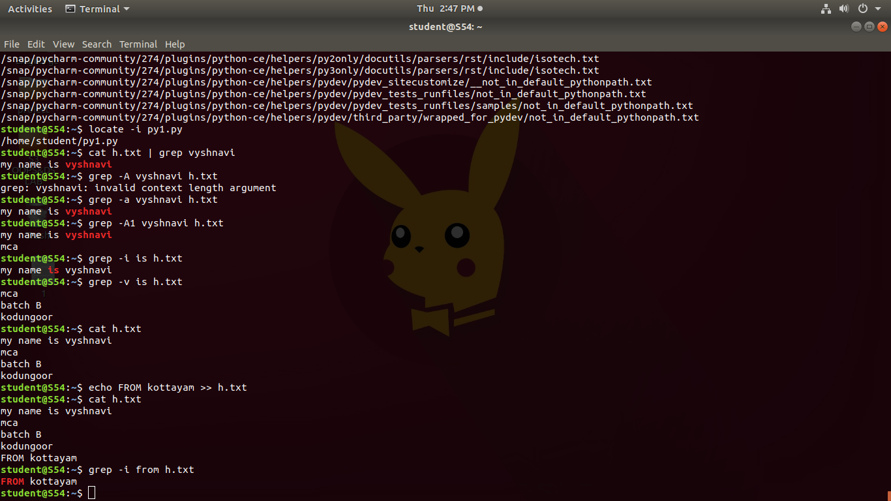

1. **grep -v is h.txt :** This prints out all the lines that do not matches the pattern.

**Syntax :** **grep -v <word in txt file><filename.txt>**

**Output:**



1. **grep -A1 vyshnavi h.txt :** Prints searched line and lines after the result.

**Syntax :** **grep -A1 <word in txt file><filename.txt>**

**Output:**

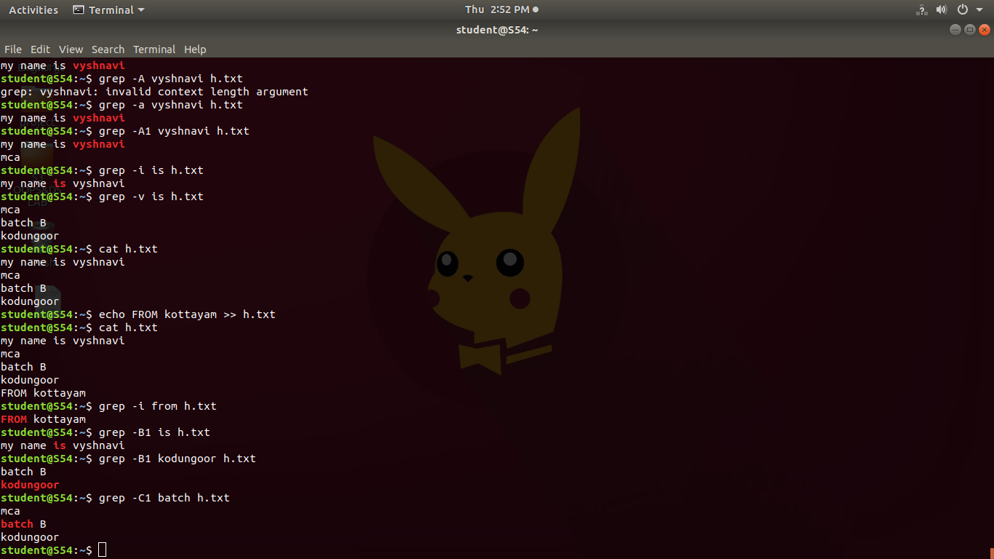

1. **grep -B1 kodungoor h.txt :** Prints searched line and n line before the result

**Syntax :** **grep -B1 <word in txt file><filename.txt>**

**Output:**



1. **grep -C1 batch h.txt :** Prints searched line and n lines after before the result.

**Syntax :** grep -C1 <word in txt file><filename.txt>

**Output:**



1. **cat h.txt | grep vyshnavi :** It is used to search text and strings in a given file.

**Syntax : cat filename.txt | grep word in txt file**

**Output:**



1. **df :** df is used to display the amount of available disk space for file systems.

**Syntax : df**

**Output:**



1. **df -m :** du is used to get report on a system in megabytes

**Syntax : df -m**

**Output:**

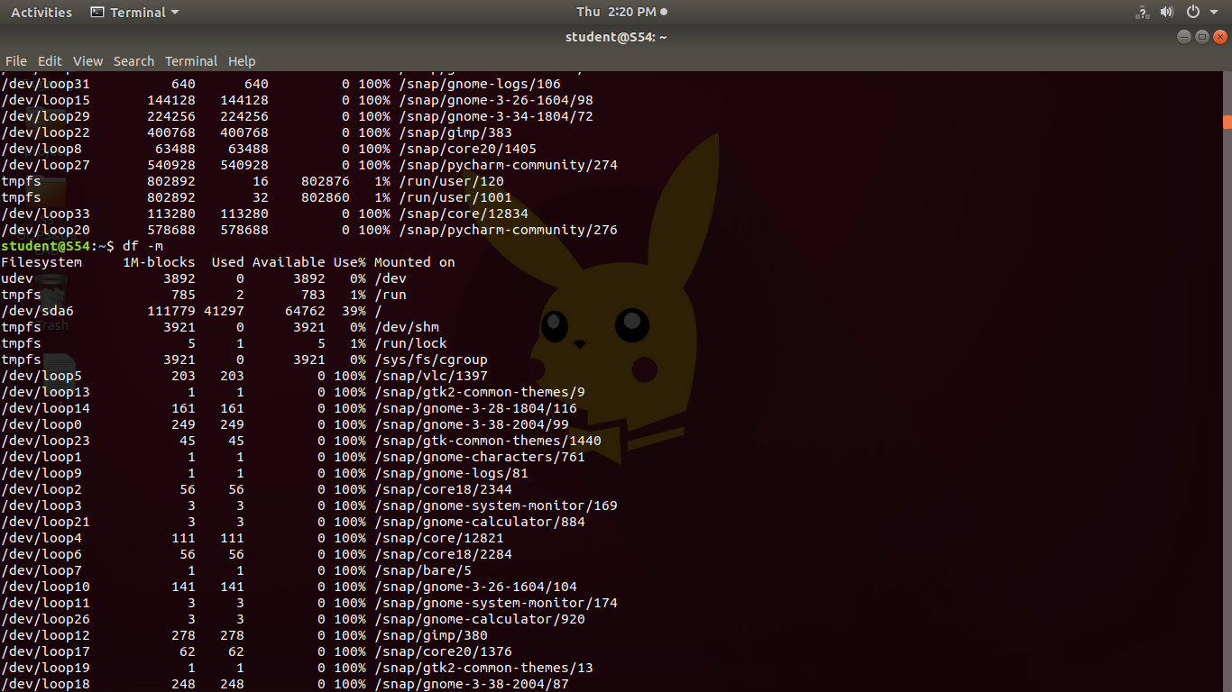

1. **du :** du is use to check directory/file ,space usage.

**Syntax : du**

**Output:**

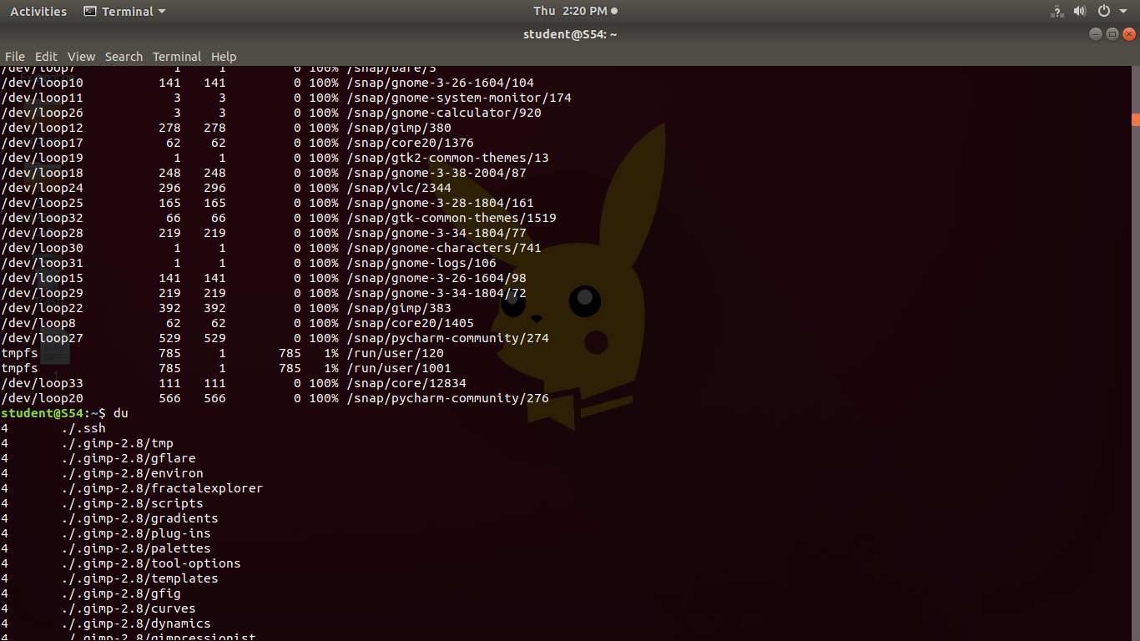

1. **wc :** wc stands for **word count.** It is used to find out number of lines, word count, byte and characters count in the files specified in the file arguments.

**wc -l h.txt :** This option prints the **number of lines** present in a file.

**Syntax :** **wc -l filename.txt**

**Output :**



1. **wc -w h.txt :** This option prints the **number of words** present in a file.

**Syntax : wc -w filename.txt**

**Output:**



1. **wc -c h.txt:** This option displays **number of characters** present in a file.

**Syntax : wc -c filename.txt**

**Output:**



1. **wc -m h.txt :** This option displays **count of bytes** present in a file.

**Syntax : wc -m filename.txt**

**Output :**

